The WRIGHT Kennel
Phone: 905-263-4510 Email: GermanShepherd@bellnet.ca
Christine Wright Cell: 905-430-0444

2733 Taunton Road East, Bowmanville, ON L1C 7B1
Home of Champion Pure-Bred King German Shepherds

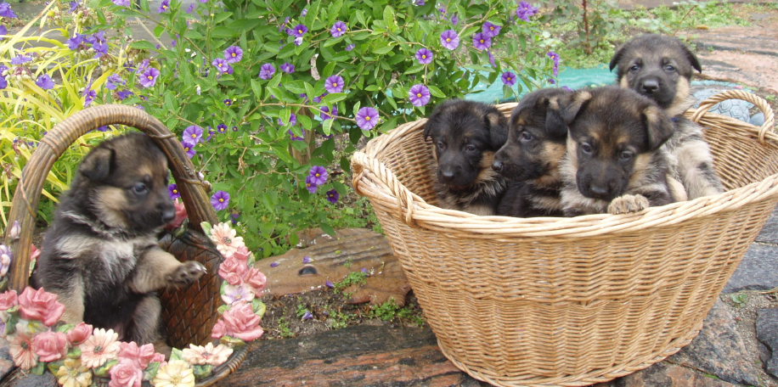

PURCHASE RECEIPT
Received today _________ ____ 2021, in the Town of Bowmanville, the sum of $350.00 non-refundable deposit for the purchase of a German Shepherd puppy. Purchase price is $2,299.00 including full vet examination at 6 weeks, first vaccinations, microchip, de-worming treatment, several days of food, Royal Canin puppy care / instruction kit, $30 of coupons for excellent food products, plus 30 pages of complete written feed and care instructions. We ask for $250.00 additional non-refundable deposit when your puppy is born and full payment upon puppy pick-up at 7-8 weeks of age.

You are welcome to come visit us and your puppy any week you want at our home in Bowmanville and the best days of the week for us are Wednesdays & Sundays since we are home all day. If it is easier for you to pick up your puppy at our Scarborough Toronto East office you are welcome to do so. We discourage touching of newborn puppies for the first three weeks but you are welcome to view and ask any questions. We usually do three litters of puppies each summer – an average of 24 puppies – and most are pre-sold from our waiting list or when we do advertise at time of birth, they are all sold within a week. We feel that our loving wonderful care, our beautiful home with so much property for the dogs to run & play, a fully equipped farm / barns / kennels, the dogs themselves and over 35 years of experience contribute to new owners feeling confident with our excellent environment for raising puppies.

The deposits can be made by cheque, debit or e-transfer, but final payment must be paid CASH upon delivery. Please bring a suitable carrying case to transport your puppy for the drive home. We will provide you with 3 weeks written notice (actually you will know that pickup is 7 – 8 weeks from date of birth) and a 3 day window Friday through Sunday to pick up your puppy after the first veterinarian visit at six weeks. Hopefully one of these days will suit you since thereafter we do charge an additional $85 per day for a maximum of 5 days. We apologize for this but it is such a considerable amount of work to care for only one puppy when all others have left for their new homes – that one puppy is so lonely and needs constant care when all his / her siblings have left!

We ask you to please complete the following information for us – we love our puppies to pieces after handling them every day for 8 weeks so we want them to go to the best possible homes where they are loved and cared for:
- Your name, address, phone number, email address.
- Please provide us with a description of your home and persons living with you so that we know you have a good environment for a large breed dog, thank you.
- Are you familiar with the German Shepherd breed? Please provide some details.
- Do you want a male or female puppy?
- Do you want a large boned dog or a regular size dog, based on our observance of the puppy’s growth?
- Do you want a quiet or out-going puppy, based on our observance of the puppy’s growth?
- Do you prefer colors of silver & black, blonde & black, or red & black?

Please any changes to the above information and purchase agreement must be done in writing to our email address above.
THANK YOU & ENJOY SO MUCH PUPPY LOVE!!!

